
Transforming the lives of vulnerable people

Will you join us?

Maintenance and Void Operative

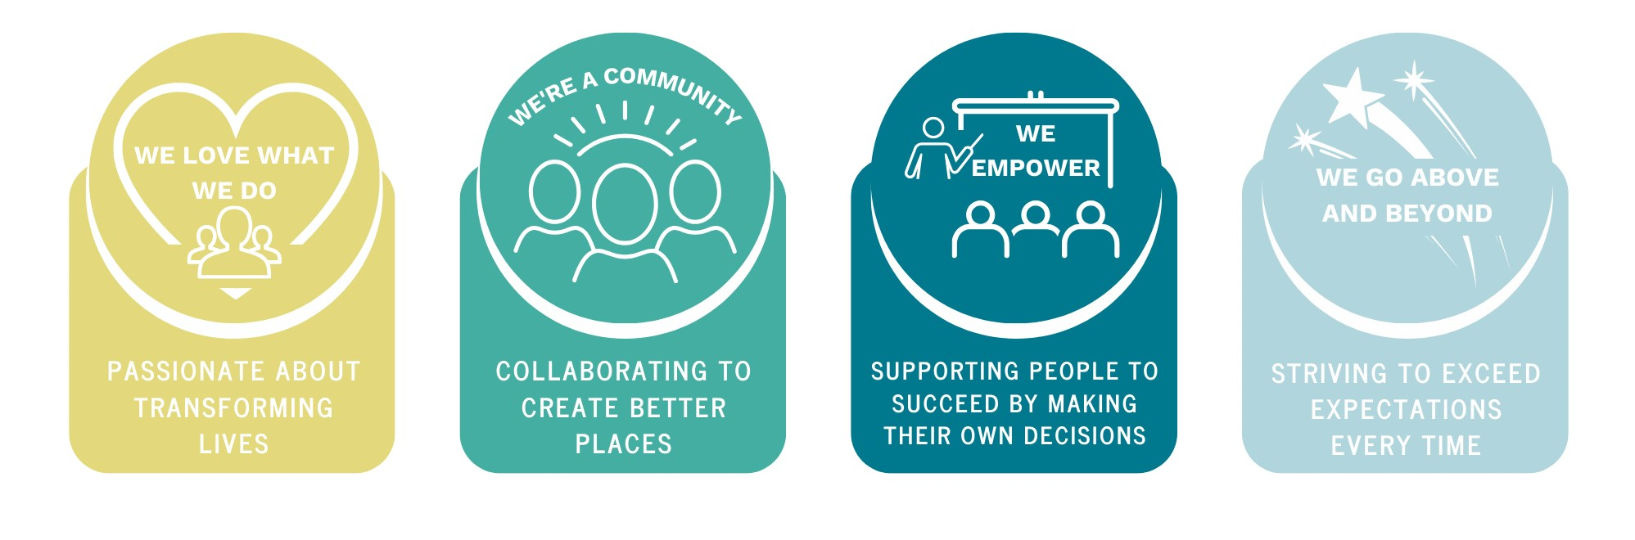

Purpose of the Role
At Bedspace we’ve made it our mission to do one thing: transform the lives of vulnerable people. Our team of 300+ people work to provide housing and support packages to our service users in asylum, young people leaving care, adults in social care and homeless families and individuals. 2024 sees us celebrate our 25th anniversary, in which time we’ve supported over 17,000 vulnerable people to transform their lives.

Position in the organisation
This position reports to the Maintenance/Voids Manager and sits within the Housing and Property team.
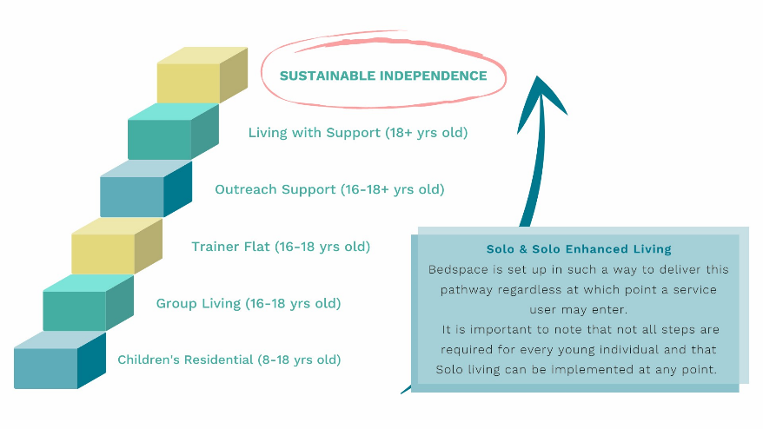

The Bedspace pathway allows for the right support at the right time for the individual and has the goal of them achieving sustainable independence.

Overview
The Maintenance and Voids Operative is responsible for providing comprehensive, responsive and efficient maintenance and repair to both Bedspace void properties and our service users living in Bedspace properties.

You will be expected to lead by example, reinforcing Bedspace's core Values.

The Maintenance and Voids team ensure that all our properties are safe, well-maintained & liveable.

To be responsible for allocated maintenance tasks from start to completion including the scoping, pricing and ordering of materials, liaising with the managers and undertaking the work personally or coordinating and supervising others to ensure its timely completion.
The people we support often have complex emotional and social needs and as part of our front line team you will need to empathise and help develop supportive and positive relationships with them.

About you

For a successful application, you’ll need to have experience in property maintenance.

You will be able to demonstrate a wide range of skills, including floor laying, changing locks, painting & decorating, plastering & joinery skills.

You will have a specific & demonstratable knowledge in one field of the above skills – ideally trade qualified but this is not essential. You will be willing to undertake further training.

You will have experience in inspecting vacant properties on notification by the head of services, ensuring necessary repair works are documented and completed timeously within the target period.

You are professional and values-led with integrity, inclusivity and respect for diversity, with an ability to work in an ever-changing environment whilst maintaining a positive & caring approach.

You’ll have a sense of humour, be personable and accept that things won’t always go to plan.

You can adapt to changing and emerging needs, demonstrating flexibility and resilience in challenging situations. You have a knowledge of Bedspace and a belief in its values and principles.

Key Accountabilities and Responsibilities
- Respond to colleagues’ reports of repairs required to tenanted and other properties. Decide or approve necessary action, and the appropriate response time required in accordance with Bedspace policy and procedures; check, authorise & deliver work to be carried out, contact contractors when necessary or provide advice to in-house coordinators on timescales & completed dates.

- Carry out minor and/or major repairs, or interim emergency repairs, where this is necessary or cost-effective.

- Undertake pre and post-inspections of reactive maintenance works in accordance with agreed procedures and sampling methods when requested.

- Coordinate and process adaptation requests for people with medical problems or disabilities in accordance with Bedspace policy, as approved by the Housing Services Manager.

- Undertake pre and post-inspections for maintenance and service contracts. Provide monitoring and action reports in accordance with agreed standards and procedures, distributing these to the head of service upon request.

- Provide instruction and demonstration in the use of and location of services to new tenants, housing management colleagues and project-based colleagues working in Bedspace properties.

- Identify requirements for site security, safety and maintenance of new sites and vacated properties, where necessary in conjunction with the appropriate development or housing management colleagues.

- Ensure all necessary reporting via the Remas and any other relevant Bedspace systems is undertaken for audit purposes.

- Provide temporary cover in other Maintenance technicians areas when they are absent.

- Arrange for and maintain records of appliance testing in Bedspace properties as required.

- Clean properties where requested following void work that the technician has undertaken

- Undertake house removals where the business deems it necessary & also provide a furniture delivery service as directed by the coordinators and head of service.

We are looking for someone who…..
- To adhere to clear KPIs set by the head of service
- Stringent recording of works completed via an internal maintenance recording tool.
- To be responsible for allocated maintenance tasks from start to completion
- Scoping of works and preparing any necessary reports
- Pricing and ordering of associated materials where required – being mindful of best value
- Carry out the regular maintenance work of the head office buildings where necessary
- Monitor Day-to-day maintenance expenditure using a credit card app and trade cards
Health and Safety
The post holder is required to carry out the duties in accordance with the company's Health and Safety policies and procedures.
Diversity
The post holder is required to always have due regard to equal opportunities, and to work fairly and reasonably towards all people, ensuring service standards are maintained for all cultures.
Confidentiality
The post holder is required to observe and maintain strict confidentiality with respect to guests, clients and all company information.

Person Specification and Selection Criteria
Skills & Knowledge | Essential (E) or Desirable (D)
Ability to handle all aspects of painting and decorating, basic plumbing, basic electrical and joinery – ideally specialising in one area. | E
Willingness to take ownership of resolution of issues | E
Ability to quickly interpret data and information, and recognise inconsistencies | E
Excellent organisational and time management skills | E
Tact and diplomacy, together with a confident personality | E
Clear thinking and calm approach | E
Excellent interpersonal and communication skills | E
Understanding of and commitment to the business practices of Bedspace Resource Ltd. | E
Ability to deal effectively with delegated projects from initial contact to completion without direct supervision. | D
Ability to work under pressure and deal with unforeseen issues in ever-changing circumstances. Ability to operate in a sensitive political environment. | E
Qualifications/Requirements | Essential (E) or Desirable (D)
Driving Licence | E
Professionally qualified within an essential maintenance-related field i.e. NVQ level 3 or similar demonstratable experience | D
Well-developed personal and written communication skills, including the ability to communicate with a wide range of staff and members. | E
Satisfactory DBS Disclosure | E
Willingness to undertake further training | E
Experience | Essential (E) or Desirable (D)
Relevant experience in Maintenance of social care, hostel local authority setting | D
Efficient reading skills with the ability to assess and comprehend written information quickly and accurately. | E
Capable of following procedures and systematic processes. | E
Ability to input accurate information onto Bedspace internal systems eg ReMaS/Arthur. | E

Essential requirements are those, without which, the post holder would not be able to fulfil the responsibilities of the role.
Desirable requirements are those which would be useful for the post holder to possess and will be considered when more than one applicant meets the essential requirements.

The above list of responsibilities is not exhaustive, and the jobholder may be required to undertake other duties commensurate with the level of the role, as reasonably requested by their line manager. This job description sets out the duties of the post at the time it was drawn up. Such duties may vary from time to time without changing the general character of the duties or level of the responsibility entailed. Such variations are a common occurrence and cannot in themselves justify a reconsideration of the grading of the post.

This post will be subject to a satisfactory Enhanced Criminal Record Check from the Disclosure and Barring Service (England & Wales). If you require further information regarding this check, please contact careers@bedspace.co.uk

Our Values
To enable us to achieve our desired culture we have the following values which we live by:
 | 
 | 



